Solidarity Protest
MEET: Spanish Consulate, 63 North Castle St, Edinburgh EH2 3LJ
FRIDAY 6 Feb – FROM 12:00noon
HARASSED! CHARGED! IMPRISONED! FOR BEING ANARCHISTS!
by ‘operación Pandora’ in Spain
‘Un movimiento que olvida a sus presos está condenado a la derrota’
‘A movement that forgets its prisoners is doomed to defeat’

On 16/12/2014 Mossos d'Esquadra (Catalan “independent” police ‘squaddies’) stormed 14 homes and social centers in Barcelona and Madrid, destroying or stealing everything of value. Without concrete accusations and with the greatest secrecy, 11 anarchists (7 women and 4 men) were sent to a High Court in Madrid. 4 were released two days later with charges - and 7 stayed in prison until they were eventually released on extortionate bail of €3000 each on 30/01/2015, one is a member of the CNT-AIT Union. The anarchists continue to endure harassment, charges and secretive Court proceedings because of their criticism and opposition to capitalism and the state.
drop the charges!
_____________________________________________________________________________
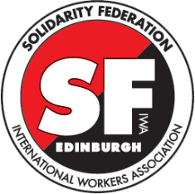
Edinburgh Solidarity Federation, c/o ACE, 17 West Montgomery Place,
Edinburgh EH5 7HA | edinburghsf@riseup.net | www.solfed.org.uk
International Workers’ Association, Targowa 22 lokal 27 a03-731
Warszawa, POLSKA | secretariado@iwa-ait.org | www.iwa-ait.org
further information: efectopandora.wordpress.com

