Solidarity Protest
MEET: Spanish Consulate, 63 North Castle St, Edinburgh EH2 3LJ
FRIDAY 23 JAN – FROM 12:00noon-2pm
We will begin handing out flyers and raising awareness about the prisoners before and after - please get involved and join us!
Free the 7 Anarchists detained for their political beliefs by ‘Operación Pandora’ in Spain
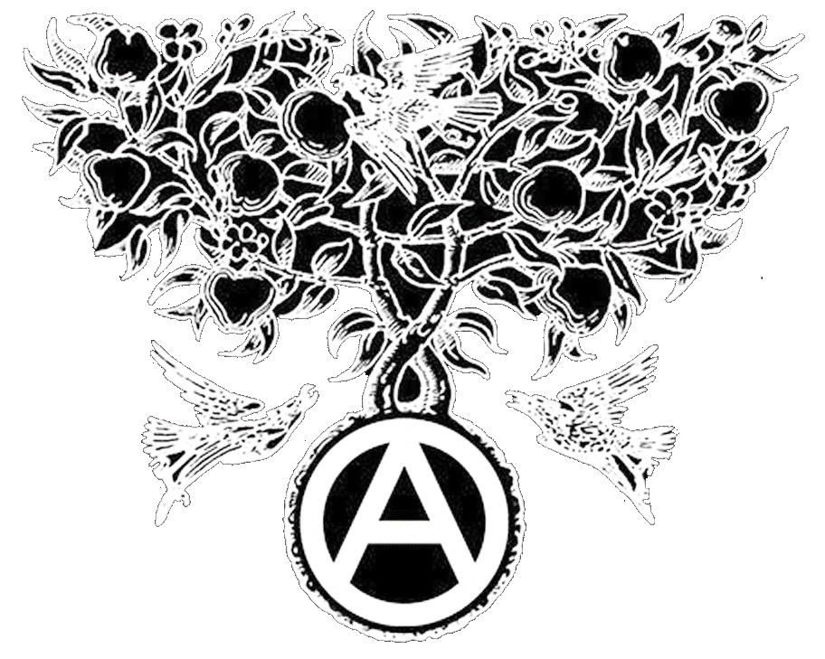
On 16/12/2014 the Mossos, Catalan police stormed 14 homes and community centers, destroying and stealing everything they could find of value. Without making any specific accusations and acting in complete secrecy, 11 anarchists were transferred to the National Court in Madrid. 4 were released two days later - and 7 have ended up in prison, one is a member of the CNT-AIT Union. They are all facing secretive Court proceedings.
we want them free!
✉ Edinburgh Solidarity Federation, c/o ACE, 17 West Montgomery Place, Edinburgh EH5 7HA | edinburghsf@riseup.net | www.solfed.org.uk

